Third Party Inspection  of  Passenger Elevator | SGS Pakistan (Pvt.) Ltd.  Plot # 4, Sector - 24  Korangi Industrial Area,  Karachi - PAKISTAN.  Tel: +92 21 35121388  Fax:+92 21 35121325 / 35121386  Web Site: www.sgs.com
 | Inspection Report

Client | : | IITC
Client Ref | : | Email Dated: 20th June, 2026
Client Contact Person | : | Mr. Ali Hasan
SGS Ref. No. | : | 5034500
Inspected by | : | Sumair Ahmed (Asst. Manager)
Site | : | Naya Nazimabad, Karachi
Equipment Identification | : | Passenger Lift
Survey Date | : | 27th March, 2025
QR Code | :
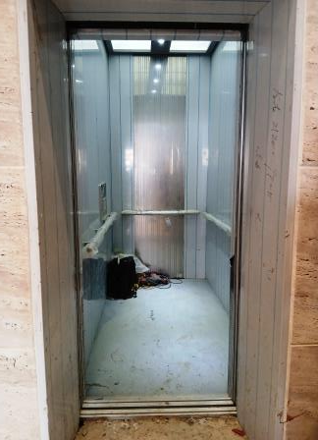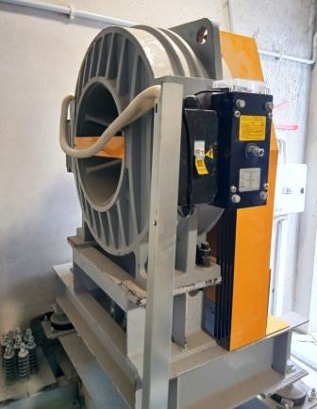

Prepared by : | Reviewed by:
Sumair Ahmed  Asst. Manager | M. Rafi Shah  Assistant Manager

